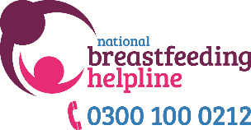

**Reporting a Concern Form**

**Reporting Concerns About a Child/Vulnerable Adult**

You must raise and discuss your concerns, without delay, with a BfN Supervisor, ABM BFCC or Project Co-ordinator or Line Manager.

**If you are unable to discuss your concerns locally, and you think the concern is urgent and someone is in immediate danger, do not delay – call 999, or your local safeguarding teams (Safeguarding Children Partnership/Adult Safeguarding Board).**

**DO NOT INVESTIGATE** the situation yourself, but you **DO** have a duty to report the facts and seek advice.

If you still have a concern after consulting with the above, please follow and complete this form below with as much information as you have, use this form to record every conversation relating to the concern - do not delay in sending this form if you don’t have all the information.

**Email the final completed form to BfN safeguarding leads (who are also Programme Managers) -** **projects@breastfeedingnetwork.org.uk** **and cc in** **felicity.lambert@breastfeedingnetwork.org.uk****.   
If you are an ABM volunteer also copy in** **Caroline.bolton@breastfeedingnetwork.org.uk**

Refer to BfN and ABM’s full safeguarding policies when completing this form.

|  |  |  |
| --- | --- | --- |
| **Details of child and parents/carers**  Please keep personal details in accordance with IG policy and local practice, ready to be shared appropriately if/when necessary**.** | | |
| **Your name:** | **Peer support activity:** | **Date and time of concern raised:** |
| **Your BfN Supervisor/coordinator/ line manager/NBH Helpline Volunteer Co-ordinator/ABM BFCC name:** | **Date and time of concern raised** | |
| If you are responding to concerns raised by someone else, please describe who e.g. supervisee/fellow volunteer/staff member and place of concern e.g. phone/group/home visit | | |
| **Please provide details (without names) of the incident or concerns you have,** including times, dates, description of any injuries, whether information is first hand or the accounts of others, was anyone else present that witnessed the incident or shared concerns, including any other relevant details – keep notes factual: | | |
| Remember concerns should be discussed with the family **unless**:   * the view is that a family member might be responsible for abusing the child * someone may be put in danger by the parents being informed * informing the family might interfere with a criminal investigation.   **Record/Summary of Discussion with family (date and time)** | | |
| **Record/Summary of discussion with Supervisor or Project co-ordinator/line manager or NBH Helpline Volunteer Co-ordinator/ABM BFCC (record date and time of each discussion):** | | |
| **Record/Summary of discussion with local safeguarding lead where relevant (record date and time of each discussion):** | | |
| **Record/Summary of discussion with BfN/ABM safeguarding lead (projects@breastfeedingnetwork.org.uk/caroline.bolton@breastfeedingnetwork.org.uk) (record date and time of each discussion):** | | |
| **If you are unable to discuss your concerns with responsible safeguarding persons locally or within BfN, and you think the concern is urgent and someone is in immediate danger,** **do not delay – call 999, the NSPCC** **0808 800 5000****, or your local safeguarding board .**  NSPCC - Helpline (24 hours a day 365 days a year)  Safeguarding children partnership team/Safeguarding adults Boards/MASH - You should find the contact details on your local authority/council website by searching for safeguarding or child protection | | |
| **Summary of discussion with NSPCC (if relevant) (record date and time of each discussion):** | | |
| **Summary of discussion with Local Safeguarding Children Partnership/Local safeguarding adult board/MASH (if relevant) (record date and time of each discussion):** | | |
| **Summary of 999 call (record date and time of each discussion):** | | |
| **After discussions with the above is there still child/adult safeguarding concerns?**  Yes/No (delete as appropriate) | | |
| Remember safeguarding concerns are rare, it is important to share your concerns with the right people (as listed above) – do not delay in talking to someone.  NB. At this point, whether there are still concerns or not, please email this form to BfN or ABM safeguarding leads if not already done so to: projects@breastfeedingnetwork.org.uk or caroline.bolton@breastfeedingnetwork.org.uk  This information will help us to review the policy and develop our safeguarding training. | | |
| **GREYED OUT SECTIONS BELOW ARE TO BE COMPLETED TOGETHER WITH YOUR SUPERVISOR / COORDINATOR/BFN SAFEGUARDING LEAD/ABM BFCC** | | |
| Are you aware of any previous incidents or concerns relating to this child/adult and of any current risk management plan/support plan? If so, please provide details: | | |
| Have you informed the statutory child protection authorities (highlight your answer)?  **Police**: Yes/No Date and time:  Name and phone number of person spoken to:  **Local authority safeguarding children/adult safeguarding contact**:  Yes/No Date and time:  Name and phone number of person spoken to:  Action agreed with authorities: | | |
| What has happened since referring to statutory agency(ies)? Include the date and nature of feedback from referral, outcome and relevant dates: | | |
| If the concerns are not about child protection, details of any further steps taken to provide support to child and family, and any other agencies involved: | | |

**Appendix 5: Life threatening situations on the NBH/web chat/social media messages**

This document outlines the process for a volunteer on NBH, BFN or ABM helplines who receives a call that indicates a ‘life threatening’ event - where the caller’s phone number needs to be flagged urgently.

**Remember these situations are extremely rare, so please don’t panic about this – these instructions are here just in case.**

If anything distressing ever happens on a helpline call, or if you want to talk through anything at all, please contact your Helpline Volunteer Co-ordinator /Supervisor/ABM BFCC.

**No helpline volunteer should ever feel that they have to cope with anything on their own.**

**Life threatening events** **may include:**

* Situations where a caller says they are about to attempt suicide.
* Situations where a caller says she is in immediate serious danger from a partner or someone else.
* Situations where there is an immediate danger that the caller may seriously harm her baby or someone else.

**Life threatening events are not:**

* If a caller is being abusive or threatening (there is a separate procedure detailed at the bottom of this document for identifying these callers)
* If you have concerns about the health of a baby referred to in a call - e.g. the baby needs to go to hospital – follow normal procedures (e.g. urge parents to seek medical help and seek supervision for yourself).

**In a life threatening situation…**

* **If the caller is willing and able to give you their contact details, phone number, address etc – make a careful note of these.**
* Encourage the caller to dial 999 and access help for themselves immediately.
* When the call ends, call 999, explain the situation (e.g. ‘I’m a volunteer on the National Breastfeeding Helpline and a caller has just told me the following… Her contact details are… /she can be found at….’)
* **Let a Helpline Volunteer Co-ordinator or ABM BFCC know what has happened, and seek supervision and support.**
* **If the caller is not willing/able to give you any contact details:**

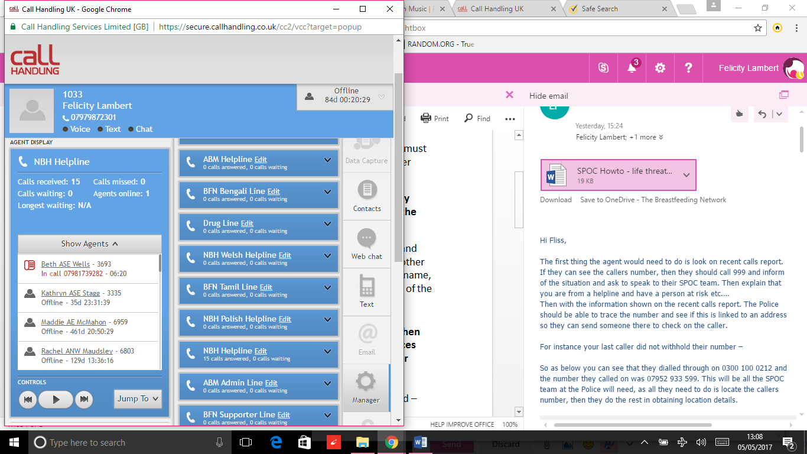

If the callers number is displayed on the virtual call centre (usually in red underneath your name on the ‘show agents’ drop down list), make a note of this number.

012345678910

Volunteer name

* Encourage the caller to dial 999 and access help for themselves immediately.
* When the call ends, if you have the caller’s number, call 999, explain the situation (e.g. ‘I’m a volunteer on the National Breastfeeding Helpline and I need to speak to someone on your SPOC team (**Single Point of Contact team) -** a caller is at risk, she has just told me the following… Her phone number is…)
  + The Police SPOC team should be able to trace the number and see if this is linked to an address so they can send someone there to check on the caller.
* **Let a Helpline Volunteer Co-ordinator or ABM BFCC know what has happened, and seek supervision and support.**
* **If the call ends *before* you have a chance to note the caller’s number down**, a Helpline Volunteer Co-ordinator, ABM BFCC or Helpline Manager *may* be able to find the caller’s number for you. You should still call 999 first and explain the situation before trying to contact a helpline staff member to identify the caller’s number.
  + Email HVC@breastfeedingnetwork.org.uk and abmbfcc@breastfeedingnetwork.org.uk and if possible post on the NBH Facebook group too, or text your own HVC/BFCC if you have their number. Whichever staff member sees your email or message first will do their best to help you find the number.
* **Withheld Numbers**

If a caller has withheld their number it will appear on the Virtual Call Centre as ‘in call’ only, with no number next to it. Helpline Volunteer Co-ordinator and BFCCs have no way to access this number either. With police involvement, there are ways the telephone network can trace withheld numbers, but this is usually provided only in very extreme circumstances, where life is at threat.  
**In this situation you should:**

* Encourage the caller to dial 999 and access help for themselves immediately.
* Encourage the caller to share their contact telephone number with you if possible – if they do then just follow procedure 1 listed above.
* If they won’t/don’t give you their details, then when the call ends, dial 999, explain the situation (e.g. ‘I’m a volunteer on the National Breastfeeding Helpline and I need to speak to someone on your SPOC team (Single Point of Contact team) **-** a caller is at risk, she has just told me the following…
* The police will have to obtain the number from our telephone network, **KCOM Communications,** as Call Handling are not allowed to pass on the caller’s telephone number under any circumstances.
* You will need to give the police this email address: **spoc@kcom.com** for them to be able to get the phone number from KCOM.
* You will need to provide these details:

KCOM will have **Call Handling Services** listed as the owner of the number (not National Breastfeeding Helpline). Our helpline number is supplied by KCOM *via* Call Handling Services.

* + **Account name – Call Handling Services**
  + **Time of call** – (e.g.) 12:41
  + **Dialled number** – (e.g.) 0300 100 0212
  + **Duration of call** – (e.g.) 15:38
  + **Any other information** that may help with tracing the call – e.g. background noise, name, accent of the caller.
  + **Your name and the name of the organisation** you are calling from.
* **Let a Helpline Volunteer Co-ordinator or BFCC know what has happened, and seek supervision and support.**

**CONTACT DETAILS:**

You can contact all the BFN Helpline Volunteer Co-ordinators (including the NBH Manager) on HVC@breastfeedingnetwork.org.uk

You can contact the ABM BFCCs on: abmbfcc@breastfeedingnetwork.org.uk

In an emergency situation, please cc both addresses to ensure someone picks it up sooner.

**Nuisance or abusive callers**

Callers who are abusive or calling repeatedly can be blocked by Call Handling.

If you have the phone number of the caller from the virtual call centre screen, please email felicity.lambert@breastfeedingnetwork.org.uk and she will pass this on to Call Handling and ask for them to block the caller. Usually this can only happen inside office hours.

If the caller has withheld their number, please also email felicity.lambert@breastfeedingnetwork.org.uk with these details:

* approximate timing of the call – start and end
* dialled number (which Helpline number – NBH/ABM/BFN etc..)
* any other information that may help with tracing the call – e.g. background noise, name, accent of the caller.

There is a similar process to the emergency procedure above to follow, but the Helpline Manager will complete the process for you.