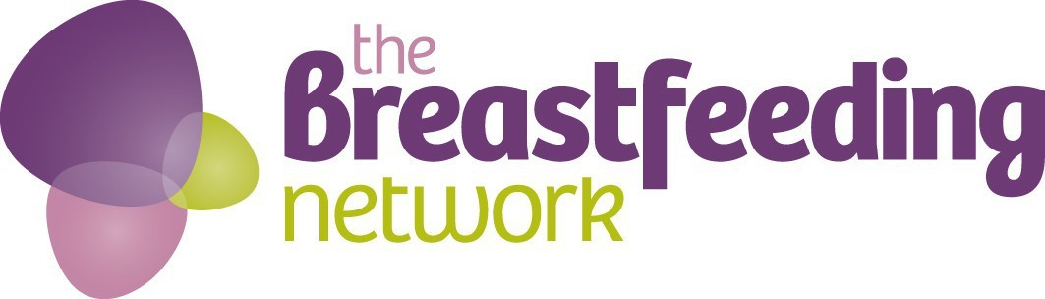

Capability Statement

About the Breastfeeding Network
The Breastfeeding Network has over 19 years of providing breastfeeding peer support working in communities where breastfeeding rates are at their lowest. We have experience of providing commissioned support in a variety of settings using targeted and universal approaches with a mix of trained staff and volunteers, working with health care professionals (HCPs).

Since 2008 we have run the National Breastfeeding Helpline in collaboration with volunteers from the Association of Breastfeeding Mothers and have run with multiple minority language lines. We also run a unique information service dedicated to informing and supporting women on the impacts of medication and medical treatments on breastmilk – Drugs in Breastmilk Line.

Examples of the type of support Breastfeeding Network peer supporters can offer
- Group support in community based breastfeeding centres working with HCPs or independently
- 1:1 support via telephone or text messages – providing early days support post discharge from hospital and up to 4-6 weeks after birth
- 1:1 support with a named peer supporter providing support as required by each family – often targeted to specific areas in a way which suits the family (phone, home visits or text messages)
- 1:1 support on the wards within a hospital – may include maternity, pediatric and neonatal units. Peer supporters can offer emotional support as well as support with breastfeeding to complement the work of midwives and others on the ward. This can also include signposting to ongoing 1:1 support or community based group support.
- Breastfeeding support and access to supportive communities online via social media (Facebook/Twitter) both locally and nationally
- Antenatal input including 1:1 support, antenatal classes and support at groups
- Evidence based information and support to women encouraging introduction of appropriate solid foods at the recommended time of around six months – alongside continued breastfeeding or other milk feeds
- Brief interventions and signposting to other important services, eg targeted support for teenage mums, smoking cessation, healthy lifestyles support, domestic abuse support, maternal mental health, infant mental health and development

Support includes both skilled breastfeeding support and simple but powerful mum-to-mum social and emotional support, helping families to build supportive networks and reduce isolation.

Training & Quality Statement
We offer two levels of training – to Helper and Supporter level. Both are fully accredited by Open College Network (OCN). We have Direct Claims Status (DCS), that is status built on trust and confidence and symbolises that BfN has robust quality systems which support effective decision making in respect of learner standards.

The Breastfeeding Network training meets with UNICEF Baby Friendly Standards and we have years of experience of working with partners to achieve and maintain UNICEF BFI accreditation. As an organisation we are committed to being WHO Code Compliant in every aspect of our work.

Our Past Performance & Impact
We are pleased to report good performance across all our peer support schemes.
A 2016 evaluation with parents and health professionals showed that families valued the support offered:
- 82% said BfN support had helped them address their breastfeeding challenges.
- 64% reported that BfN support helped them feel more confident to breastfeed, and reduced isolation (was this the same question?
- 68% said it made them feel they were not on their own.

The evaluation also showed that support had a wider community impact:
- 83% said that their experience of receiving support from BfN had made them more likely to recommend breastfeeding to others
- 1 in 5 said BfN had helped them to change the attitudes of family and friends. Mothers described feeling informed and empowered and because of this they had seen family members or friends become more positive and supportive of breastfeeding.
- Over 90% of people agreed or strongly agreed that BfN support had helped them feel listened to, that their choices were respected and that mums were always at the centre of the support offered.

What makes us Unique
Our training is always offered free to women. This ensures the training can be accessible to women from all backgrounds and allows us to develop peer supporters who are representative of the families and communities they support. We work using an assets based approach, building capacity for communities to support themselves, with an emphasis on areas where breastfeeding rates are lowest to help reduce health inequalities. Once training is completed we continue to offer ongoing learning opportunities and regular clinical supervision to all volunteers and staff.

“Training to be a Breastfeeding Supporter was one of my best decisions ever. It’s been incredibly rewarding and moving to support other mums who choose to breastfeed their babies. A side effect of the thorough and interesting training is the feeling of achievement and value I’ve experienced.”

“I found the course as a whole really interesting, I found the group work and one-to-one sessions interesting as I was able to see other points of view and got to understand and appreciate other mothers experiences.”

”BfN work in a challenging environment where the service needs to challenge an inherent lack of preference for breastfeeding in the town. The service demonstrates an ability to critically review its activity to look at how it could work differently/better and is prepared to work towards challenging performance targets. … BfN are able to connect effectively with other service providers in the sector to work jointly, and are involved & engaged at a strategic level. BfN have had a major involvement in driving the delivery of UNICEF Baby Friendly Standards here. A major benefits of working with BfN is that we have the positives from working with a well-managed national organisation as well as having local management and the recruitment of peer supporters locally, essentially mums who recognise many of the difficulties of choosing to breastfeed in a less-than-encouraging environment. BfN have been able to sign up venues and businesses to the “out and about” scheme promoting breastfeeding-friendly premises. Contractual data is received on time and in good order along with quite a significant amount of additional data which I request on an ad-hoc basis. BfN is reliable and the charity has shown itself prepared to review areas of activity, priorities, costs and contract value in the face of funding restrictions.”
Commissioner of BfN Peer Support

We are flexible in our approach to supporting families from face to face peer support, to groups, to text messaging and online support, allowing families to choose the level and type of support that suits them best at each stage of parenthood.. We offer information, skilled support and links to a supportive community that can empower parents and increase their confidence to make informed choices about how they feed their baby and about parenting generally

We can also provide;
- Breastfeeding Welcome Scheme
- First Milk Matters (Breastfeeding Awareness sessions)
- Training for Peer Supporters on Neonatal wards
- Antenatal Breastfeeding classes including postnatal breastfeeding session

Charity Details
Charity Name: Breastfeeding Network
Charity Register Number: SC027007
Contact: development@breastfeedingnetwork.org.uk

Further Information
Evidence for commissioning peer support
https://www.breastfeedingnetwork.org.uk/commissioning-peer-support/

BfN training
https://www.breastfeedingnetwork.org.uk/get-involved/train-to-be-a-registered-volunteer/

Supervision
https://www.breastfeedingnetwork.org.uk/supervision-within-the-breastfeeding-network/

Evidence of Impact
https://www.breastfeedingnetwork.org.uk/evaluation/

